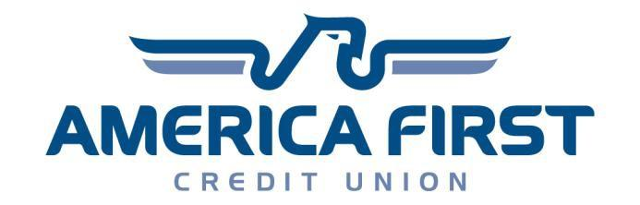

Scholarship Program Rules
Spring 2022 Financial Literacy Scholarship

Award - Up to three applicants will each receive (one) $1,250 scholarship award.

Scholarship Use
The scholarship may be used for any field of study at an accredited Title IV fund-disbursing post-secondary institution. Search here for eligible post-secondary institutions.

Eligibility
Applicant MUST:
1. Be a high school student, graduating class of 2022 or 2023, at an accredited Utah school.
2. Have successfully completed or currently be enrolled in the General Financial Literacy course or
equivalent required course.
3. If selected as a scholarship winner, applicant must show proof that you plan to pursue post
secondary education which includes acceptance letter from an eligible post-secondary institution.

Application requirements:
1. Complete online submission form located at www.utahjumpstart.org by April 15, 2022.
2. Submit required video as specified in application criteria (page 2).
3. Submit post-secondary institution acceptance letter OR document indicating student has
completed the application process and is being considered for admission.
4. Submit your video using CompleteScholarships.org by
NO later than 11:59pm on April 15, 2022. (Once students create a Complete Scholarships account, they will automatically be matched to the scholarship if they indicate their graduation year is 2022 or 2023 and that they finished or are currently enrolled in General Financial Literacy).

Selection and Judging
All qualifying entries will be judged by a panel composed of representatives from the scholarship sponsoring organizations. All decisions of the judges are final.

Deadline
All applications must be submitted via CompleteScholarships.org no later than 11:59 pm on April 15, 2022.
Utah Jump$tart Coalition Scholarship Submission Process

1. Scholarship Application Form
Complete the scholarship application form on CompleteScholarships.org

2. College Application
Recipients of this scholarship must apply for admission to any accredited Title IV fund-disbursing post-secondary institution during their senior year (seniors will be asked to upload evidence of having applied to an eligible institutions, whereas juniors will only have to acknowledge that they will apply to an eligible institution during senior year). Search here for eligible post-secondary institutions.

3. Video Rules
Submit a 60 second YouTube video addressing the following questions:

“What are 3 important skills from your financial literacy class that will help you prepare for college and life after college?”

Students will receive points based on their content, creativity and must meet following requirements:
- Emphasize a resource to plan for college.
- Video must be in English, must be the entrant’s original work and not infringe on any copyrights or trademarks. All music or graphics must be original or used with permission.
- Video must be no more than 60 seconds in length. Videos over 60 seconds will be disqualified.
- Video must not contain violent, obscene, immoral, defamatory, derogatory, offensive, illegal or
sexually suggestive content or contain, include, or encourage images or activities that are dangerous, unsafe, or present unreasonable risk of harm to a person or property.
- Videos should be either posted as public on YouTube and include UJSC2022 in the title
- Direct relatives of the Utah Jump$tart Coalition Board of Directors or staff are not eligible for consideration.

4. All Entries Must:
- Be publicly available on YouTube and the link must be entered in the applicable box on the online application form located at CompleteScholarships.org.
- Be submitted by the deadline: April 15, 2022.

5. Winner Notification
Winners will be announced the end of April 2022 on Utah Jump$tart’s Twitter and Facebook pages. Winners will also be notified directly by email.

6. Scholarship Disbursement
If the student wishes scholarship funds to be deferred, they must request the deferment in writing. The Utah Jump$tart Coalition reserves the right to determine under what circumstances the scholarships may be deferred. All scholarships must be disbursed before December 2025 or be forfeited.

The Utah Jump$tart Coalition is a statewide, 501(c)3 non-profit organization dedicated to improving the financial literacy of Utah’s youth. Visit them at www.utahjumpstart.org. America First Credit Union has become one of the largest and most progressive credit unions in the country. Today, America First has 113 full-service branches and more than 800,890 members. Visit them at www.americafirst.com.

